BioFire® FilmArray® Pneumonia Panel Testing

Purpose
This procedure provides instructions for testing sputum-like specimens (induced or expectorated sputum, or endotracheal aspirates) or bronchoalveolar lavage (BAL)-like specimens (BAL or mini-BAL) using the BioFire Pneumonia Panel kit.

Background
The BioFire Pneumonia Panel is a multiplexed nucleic acid test intended for use with BioFire® FilmArray® 1.5, BioFire® FilmArray® 2.0, or BioFire® FilmArray® Torch systems for the simultaneous detection and identification of multiple respiratory viral and bacterial nucleic acids, as well as select antimicrobial resistance genes, in sputum-like specimens (induced or expectorated sputum, or endotracheal aspirates) or bronchoalveolar lavage (BAL)-like specimens (BAL or mini-BAL) obtained from individuals suspected of lower respiratory tract infection.
The following bacteria are reported semi-quantitatively with bins representing approximately 10^4, 10^5, 10^6, or ≥10^7 genomic copies of bacterial nucleic acid per milliliter (copies/mL) of specimen, to aid in estimating relative abundance of nucleic acid from these common bacteria within a specimen:
Bacteria reported with bins of 10^4, 10^5, 10^6, or ≥10^7 copies/mL
Acinetobacter calcoaceticus-baumannii complex | Klebsiella oxytoca | Serratia marcescens
Enterobacter cloacae complex | Klebsiella pneumoniae group | Staphylococcus aureus
Escherichia coli | Moraxella catarrhalis | Streptococcus agalactiae
Haemophilus influenzae | Proteus spp. | Streptococcus pneumoniae
Klebsiella aerogenes | Pseudomonas aeruginosa | Streptococcus pyogenes
The following atypical bacteria, viruses, and antimicrobial resistance genes are reported qualitatively:
Atypical Bacteria
Chlamydia pneumoniae | Legionella pneumophila | Mycoplasma pneumoniae
Viruses
Adenovirus | Human Rhinovirus/Enterovirus | Parainfluenza Virus
Coronavirus | Influenza A | Respiratory Syncytial Virus
Human Metapneumovirus | Influenza B
Antimicrobial Resistance Genes
CTX-M | NDM | mecA/C and MREJ
IMP | OXA-48-like
KPC | VIM

Principle of the Procedure
The BioFire® FilmArray® Pneumonia Panel pouch is a closed-system disposable that stores all the necessary reagents for sample preparation, reverse transcription, polymerase chain reaction (PCR), and detection in order to isolate, amplify, and detect nucleic acid from multiple lower respiratory pathogens within a single bronchoalveolar lavage (BAL)-like (BAL or mini-BAL) or sputum-like (sputum or ETA) specimen. After sample collection, the user injects hydration solution and sample combined with sample buffer into the pouch, places the pouch into a BioFire® FilmArray® Instrument, and starts a run. The entire run process takes about one hour. Additional detail can be found in the appropriate FilmArray Operator’s Manual.
Overview
The following is an overview of the operations and processes that occur during a pouch run. During a run, the BioFire® FilmArray® System:
- Lyses the sample by agitation (bead beading).
- Extracts and purifies all nucleic acid from the sample using magnetic bead technology.
- Performs nested multiplex PCR by:
  - First performing reverse transcription and a single, large-volume, massively multiplexed reaction (PCR1).
  - Then performing multiple singleplex, second-stage PCR reactions (PCR2) to amplify sequences within the PCR1 products.
- Uses endpoint melting curve data to detect and generate a result for each target on the BioFire Pneumonia Panel array.
- For the BioFire Pneumonia Panel, the system also uses real-time amplification data from the assays relative to a Quantified Standard Material (QSM) included in the pouch to provide an estimated value in genomic copies per milliliter (copies/mL) for bacterial analytes.

Specimen
Specimen Type | Bronchoalveolar lavage (BAL)-like specimens  - Including BAL and mini-BAL collected according to standard technique  Sputum-like specimens  - Including induced and expectorated sputum, as well as endotracheal aspirate (ETA) collected according to standard technique
Minimum Sample Volume | Approximately 0.2 mL (200 µL) of specimen material will be captured by the Sample Swab for transfer into the test
Transport and Storage | Specimens should be tested with the BioFire® FilmArray® Pneumonia Panel as soon as possible  If storage is required, specimens can be held:  - Refrigerated for up to 1 day (2–8 °C)
NOTE: BAL-like or sputum-like specimens should not be centrifuged, pre-processed, treated with any mucolytic or decontaminating agents (e.g. MycoPrep, Sputasol, Snap n’ Digest, DTT, sodium hydroxide, oxalic acid, trypsin, etc.), or placed into transport media before testing.
Note: In accordance with good laboratory practice recommendations, institutions should follow their own established rules for acceptance/rejection of sputum specimens (e.g. using Gram stain/Q-score) and therefore apply appropriate guidelines locally for acceptance/rejection of a sample for testing.
NOTE: Bleach can damage organisms/nucleic acid within the specimen, potentially causing false negative results. Contact between bleach and specimens during collection, disinfection, and testing procedures should be avoided.

Materials
Materials Provided | Materials Required But Not Provided
Each kit contains sufficient reagents to test 30 samples (30-test kit; RFIT-ASY-0144) or 6 samples (6-test kit; RFIT-ASY-0145):  - Individually-packaged BioFire® FilmArray® Pneumonia Panel pouches  - Single-use (1.0 mL) Sample Buffer ampoules  - Single-use, pre-filled (1.5 mL) Hydration Injection Vials (blue)  - Single-use Sample Injection Vials (red)  - Individually-packaged Sample Swabs | - BioFire® FilmArray® System including: BioFire® FilmArray® 1.5, BioFire® FilmArray® 2.0, or BioFire® FilmArray® Torch and accompanying software  - Pouch Loading Station  - 10% bleach solution or a similar disinfectant

Procedure
Refer to the BioFire Pneumonia Panel Quick Guide, the FilmArray Training Video, or the FilmArray Operator’s Manual for more detail and pictorial representations of these instructions.
Use clean gloves and other Personal Protective Equipment (PPE) when handling pouches and samples. Only prepare one BioFire Pneumonia Panel pouch at a time and change gloves between samples and pouches. Once sample is added to the pouch, promptly transfer to the instrument to start the run. After the run is complete, discard the pouch in a biohazard container.
Prepare Pouch
- Thoroughly clean the work area and the Pouch Loading Station with freshly prepared 10% bleach (or suitable disinfectant) followed by a water rinse.
- Remove the pouch from its vacuum-sealed package by tearing or cutting the notched outer packaging and opening the protective aluminum canister.
NOTE: The pouch may still be used even if the vacuum seal of the pouch is not intact. Attempt to hydrate the pouch using the steps in the Hydrate Pouch section. If hydration is successful, continue with the run. If hydration fails, discard the pouch and use a new pouch to test the sample.
- Check the expiration date on the pouch. Do not use expired pouches.
- Insert the pouch into the Pouch Loading Station, aligning the red and blue labels on the pouch with the red and blue arrows on the Pouch Loading Station.
- Place a red-capped Sample Injection Vial into the red well of the Pouch Loading Station.
- Place a blue-capped Hydration Injection Vial into the blue well of the Pouch Loading Station.
Hydrate Pouch
- Unscrew the Hydration Injection Vial from the blue cap.
- Remove the Hydration Injection Vial, leaving the blue cap in the Pouch Loading Station.
- Insert the Hydration Injection Vial’s cannula tip into the pouch hydration port located directly below the blue arrow of the Pouch Loading Station.
- Forcefully push down in a firm and quick motion to puncture seal until a faint “pop” is heard and there is an ease in resistance. Wait as the correct volume of Hydration Solution is pulled into the pouch by vacuum.
  - If the Hydration Solution is not automatically drawn into the pouch, repeat Step 2 to verify that the seal of the pouch hydration port was broken. If Hydration Solution is again not drawn into the pouch, discard the current pouch, retrieve a new pouch, and repeat from Step 1: Prepare Pouch.
- Verify that the pouch has been hydrated.
  - Flip the barcode label down and check to see that fluid has entered the reagent wells (located at the base of the rigid plastic part of the pouch). Small air bubbles may be seen.
  - If the pouch fails to hydrate (dry reagents appear as white pellets), repeat Step 2 to verify that the seal of the pouch hydration port was broken. If hydration solution is still not drawn into the pouch, discard the current pouch, retrieve a new pouch, and repeat from Step 1: Prepare Pouch.
Prepare Sample Mix

- Add Sample Buffer to the Sample Injection Vial.
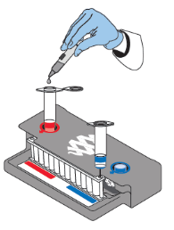
  - Hold the Sample Buffer ampoule with the tip facing up.
NOTE: Avoid touching the ampoule tip during handling, as this may introduce contamination.
  - Firmly pinch at textured plastic tab on the side of the ampoule until the seal snaps.
  - Invert the ampoule over the red-capped Sample Injection Vial and dispense Sample Buffer using a slow, forceful squeeze followed by a second squeeze.
NOTE: Avoid squeezing the ampoule additional times. This will generate foaming, which should be avoided.
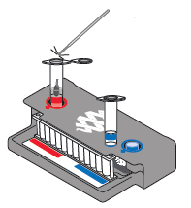
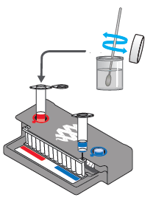
- Using the Sample Swab provided in the test kit, thoroughly stir the BAL-like or sputum-like specimen for about 10 seconds.
- Place the swab end of the Sample Swab into the Sample Injection Vial, then break off the swab handle.
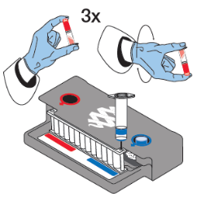
- Tightly close the lid of the Sample Injection Vial and discard the swab handle into the appropriate waste container.
- Remove the Sample Injection Vial from the Pouch Loading Station and invert the vial at least 3 times to mix.
- Return the Sample Injection Vial to the red well of the Pouch Loading Station.
Load Sample Mix
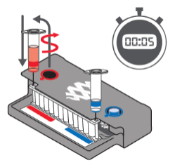
- Slowly twist to unscrew the Sample Injection Vial from the red cap and wait for 5 seconds with the vial resting in the cap.
NOTE: Waiting 5 seconds decreases the risk of dripping and contamination from the sample.
- Lift the Sample Injection Vial, leaving red cap in the well of the Pouch Loading Station, and insert the Sample Injection Vial cannula tip into the pouch sample port located directly below the red arrow of the Pouch Loading Station.
- Forcefully push down in a firm and quick motion to puncture seal (a faint “pop” is heard) and sample is pulled into the pouch by vacuum.
- Verify that the sample has been loaded.
  - Flip the barcode label down and check to see that fluid has entered the reagent well next to the sample loading port.
  - If the pouch fails to pull sample from the Sample Injection Vial, the pouch should be discarded. Retrieve a new pouch and repeat from Step 1: Prepare Pouch.
- Discard the Sample Injection Vial and the Hydration Injection Vial in appropriate biohazard sharps container.
- Record the Sample ID in the provided area on the pouch label (or affix a barcoded Sample ID) and remove the pouch from the Pouch Loading Station.

Run Pouch
The BioFire® FilmArray® Software includes step-by-step on-screen instructions that guide the operator through performing a run.

BioFire® FilmArray® 1.5 and BioFire® FilmArray® 2.0
- Ensure that the BioFire 1.5 or BioFire 2.0 system (instrument and computer) is powered on and the software is launched.
- Follow on-screen instructions and procedures described in the Operator’s Manual to place the pouch in an instrument. Enter pouch, sample, and operator information.
- Pouch identification (Lot Number and Serial Number) and Pouch Type information will be automatically entered when the barcode is scanned. If it is not possible to scan the barcode, the pouch Lot Number, Serial Number, and Pouch Type can be manually entered from the information provided on the pouch label into the appropriate fields. To reduce data entry errors, it is strongly recommended that the pouch information be entered by scanning the barcode.
NOTE: When selecting a Pouch Type manually, ensure that the Pouch Type matches the label on the BioFire® FilmArray® Pneumonia Panel pouch.
- Enter the Sample ID. The Sample ID can be entered manually or scanned in by using the barcode scanner when a barcoded Sample ID is used.
- Select and confirm the appropriate protocol from the Select Protocol dialog box. The BioFire Pneumonia Panel uses two different protocols that should be selected according to the sample type (BAL or sputum) that is being tested.
- Enter a user name and password in the Name and Password fields.
NOTE: The font color of the username is red until the user name is recognized by the software.
- Review the entered run information on the screen. If correct, select Start Run.
Once the run has started, the screen displays a list of the steps being performed by the instrument and the number of minutes remaining in the run.
NOTE: The bead-beater apparatus can be heard as a high-pitched noise during the first minute of operation.
- When the run is finished, follow the on-screen instructions to remove the pouch, then immediately discard it in a biohazard waste container.
- The run file is automatically saved in the BioFire® FilmArray® Instrument database, and the test report can be viewed, printed, and/or saved as a PDF file.
BioFire® FilmArray® Torch
- Ensure that the BioFire Torch system is powered on.
- Select an available Module (instrument) on the touch screen or scan the barcode on the pouch using the barcode scanner.
- Pouch identification (Lot Number and Serial Number) and Pouch Type information will be automatically entered when the barcode is scanned. If it is not possible to scan the barcode, the pouch Lot Number, Serial Number, and Pouch Type can be manually entered from the information provided on the pouch label into the appropriate fields. To reduce data entry errors, it is strongly recommended that the pouch information be entered by scanning the barcode.
NOTE: When selecting a Pouch Type manually, ensure that the Pouch Type matches the label on the BioFire Pneumonia Panel pouch.
- Enter the Sample ID. The Sample ID can be entered manually or scanned in by using the barcode scanner when a barcoded Sample ID is used.
- Insert the pouch into the available Module (instrument).
  - Ensure that the pouch fitment label is lying flat on top of pouch and not folded over. As the pouch is inserted, the Module (instrument) will grab onto the pouch and pull it into the chamber.
- Select and confirm the appropriate protocol from the Select Protocol dialog box. The BioFire® FilmArray® Pneumonia Panel uses two different protocols that should be selected according to the sample type (BAL or sputum) that is being tested.
- Enter operator user name and password, then select Next.
NOTE: The font color of the username is red until the user name is recognized by the software.
- Review the entered run information on the screen. If correct, select Start Run.
Once the run has started, the screen displays a list of the steps being performed by the Module (instrument) and the number of minutes remaining in the run.
- At the end of the run, remove the partially ejected pouch, then immediately discard it in a biohazard waste container.
NOTE: The bead-beater apparatus can be heard as a high-pitched noise during the first minute of operation.
- The run file is automatically saved in the Biofire® FilmArray® Instrument database, and the test report can be viewed, printed, and/or saved as a PDF file.

Quality Control

Process Controls
Two process controls are included in each pouch:
- RNA Process Control
  - The RNA Process Control assay targets an RNA transcript from the yeast Schizosaccharomyces pombe. The yeast is present in the pouch in a freeze-dried form and becomes rehydrated when sample is loaded. The control material is carried through all stages of the test process, including lysis, nucleic acid purification, reverse transcription, PCR1, dilution, PCR2, and DNA melting. A positive RNA Process Control result indicates that all steps carried out in the BioFire Pneumonia Panel pouch were successful.
- Quantified Standard Material (QSM) Control
  - The QSM assay detects a quantified standard synthetic nucleic acid that is subject to all stages of the test process following sample lysis (bead beating). A positive QSM control result indicates that the expected level of QSM is present (approximately 10^6 copies/mL) for use in determining assay and bin results for bacterial analytes.
Monitoring Test System Performance
The BioFire® FilmArray® Software will automatically fail the run if the melting temperature (Tm) for either the RNA Process Control or the QSM is outside of an acceptable range (80.3–84.3°C for the RNA Process Control and 82.7–86.7°C for the QSM). If required by local, state, or accrediting organization quality control requirements, users can monitor the system by trending Tm values for the control assays and maintaining records according to standard laboratory quality control practices. Refer to the appropriate FilmArray Operator’s Manual for instructions on obtaining control assay Tm values.

Interpretation
The BioFire Software automatically analyzes and interprets the assay results and displays the final results in a test report (see the BioFire® FilmArray® Pneumonia Panel Quick Guide to view an example of a test report). The analyses performed by the BioFire Software and details of the test report are described below.
Assay Interpretation
When PCR2 is complete, the BioFire® FilmArray® Instrument performs a DNA melting analysis on the PCR products and measures the fluorescence signal generated in each well (for more information see appropriate FilmArray Operator’s Manual). The BioFire Software then performs several analyses and assigns a final assay result. The steps in the analyses are described below.
Analysis of melt curves. The BioFire Software evaluates the DNA melt curve for each well of the PCR2 array to determine if a PCR product was present in that well. If the melt profile indicates the presence of a PCR product, then the analysis software calculates the melting temperature (Tm) of the curve and compares it against the expected Tm range for the assay. If the software determines that the Tm of the curve is within the assay-specific Tm range, the melt curve is called positive. If the software determines that the Tm of the curve is not in the appropriate Tm range, the melt curve is called negative.
Analysis of replicates. Once positive melt curves have been identified, the software evaluates the replicates for each assay to determine the assay result. For an assay to be called positive, two associated melt curves must be called positive and both Tms must be similar. Assays that do not meet these criteria are called negative.
Analysis of assay results for bacteria. The assays in the BioFire Pneumonia Panel for detection of bacteria that are reported semi-quantitatively are designed to amplify genes that are present in single copies within the chromosome of the target bacterium and are used to estimate genomic copies of bacterial nucleic acid per milliliter (copies/mL) of specimen. The BioFire Software calculates an approximate value for each gene target based on real-time PCR amplification data relative to the QSM (internal reference of known quantity). Assays with no measurable amplification or a value below 10^3.5 copies/mL are called negative. Assays with a value equal to or greater than 10^3.5 copies/mL are called positive.
Organism and Antimicrobial Resistance Gene Interpretation
Each positive and negative assay result is interpreted by the BioFire Software to provide results for the identification of specific bacteria, atypical bacteria, viruses, and antimicrobial resistance (AMR) genes as shown in Table 1. For most analytes detected by the BioFire Pneumonia Panel, interpretations are based on the result of a single assay. However, results for Staphylococcus aureus, Adenovirus, and the AMR genes require interpretation based on more than one assay result, as discussed in the relevant sections below.

Table 1. Analytes Detected by the BioFire® FilmArray® Pneumonia Panel
Bacteria
Acinetobacter calcoaceticus-baumannii complex | Klebsiella oxytoca | Serratia marcescens
Enterobacter cloacae complex | Klebsiella pneumoniae group | Staphylococcus aureus
Escherichia coli | Moraxella catarrhalis | Streptococcus agalactiae
Haemophilus influenzae | Proteus spp. | Streptococcus pneumoniae
Klebsiella aerogenes | Pseudomonas aeruginosa | Streptococcus pyogenes
Atypical Bacteria
Chlamydia pneumoniae | Legionella pneumophila | Mycoplasma pneumoniae
Viruses
Adenovirus | Human Rhinovirus/Enterovirus | Parainfluenza Virus
Coronavirus | Influenza A | Respiratory Syncytial Virus
Human Metapneumovirus | Influenza B
Antimicrobial Resistance Genes
CTX-M | NDM | mecA/C and MREJ
IMP | OXA-48-like
KPC | VIM
Interpretations and Semi-quantitative Bin Results for Bacteria
The BioFire Pneumonia Panel provides a Detected or Not Detected result as well as a semi-quantitative bin result (10^4 copies/mL, 10^5 copies/mL, 10^6 copies/mL, or ≥10^7 copies/mL) for most bacteria. The bin result represents the approximate number of specific bacterial genomes in the specimen and is intended to provide a simple assessment of relative abundance of nucleic acid from different bacteria in a lower respiratory specimen based on a molecular method.
For bacteria, negative assays (no measurable amplification or value less than 10^3.5 copies/mL) are reported as Not Detected. Positive assays are reported as Detected and a bin result is assigned based on the assay value. Each bin is defined by discrete upper and lower limits spanning a 1-log range of values (see Table 2) such that the bin result reflects the assay value within the nearest ±0.5-log.

Table 2. BioFire Pneumonia Panel Bin Results for Bacteria
Assay Result |  | Reported Result and Bin Result
Negative OR | <10^3.5 copies/mL | Not Detected
Positive AND | ≥10^3.5 – <10^4.5 copies/mL | Detected | 10^4 copies/mL
Positive AND | ≥10^4.5 – <10^5.5 copies/mL | Detected | 10^5 copies/mL
Positive AND | ≥10^5.5 – <10^6.5 copies/mL | Detected | 10^6 copies/mL
Positive AND | ≥10^6.5 copies/mL | Detected | ≥10^7 copies/mL

Staphylococcus aureus
The BioFire Pneumonia Panel pouch contains two different assays (Saureus1 and Saureus2) for the detection of Staphylococcus aureus. The BioFire® FilmArray® Software interprets each of these assays independently (as described above), and if one or a combination of the assays is positive, the result will be Staphylococcus aureus Detected with the appropriate bin result. If both assays are negative, the result will be Staphylococcus aureus Not Detected.
NOTE: Detection of bacterial nucleic acid may be indicative of colonizing or normal respiratory flora and may not indicate the causative agent of pneumonia. Semi-quantitative Bin (copies/mL) results generated by the BioFire® FilmArray® Pneumonia Panel are not equivalent to CFU/mL and do not consistently correlate with the quantity of bacterial analytes compared to CFU/mL. For specimens with multiple bacteria detected, the relative abundance of nucleic acid (copies/mL) may not correlate with the relative abundance of bacteria as determined by culture (CFU/mL). Clinical correlation is advised to determine significance of semi-quantitative Bin (copies/mL) for clinical management.
Interpretations for Atypical Bacteria and Viruses
Results for most atypical bacteria and viruses are reported as Detected or Not Detected based on an individual corresponding assay result. If the assay is positive the result will be Detected, and if the assay is negative, the result will be Not Detected. However, Adenovirus detection is reported based on the results of multiple assays, as described below.

Adenovirus
The BioFire Pneumonia Panel pouch contains three different assays (Adenovirus2, Adenovirus3, and Adenovirus7) for the detection of all species and serotypes of Adenovirus. The BioFire® FilmArray® Software interprets each of these assays independently (as described above) and the results are combined as a final result for the virus. If one or any combination of assays is positive, the result will be Adenovirus Detected. If all assays are negative, the result will be Adenovirus Not Detected.
Interpretations for Antimicrobial Resistance (AMR) Genes
Results for AMR genes are also reported qualitatively (Detected/Not Detected) based on corresponding assays, but only if an applicable bacterium (i.e. potential carriers of the AMR gene; Table 3) is also detected (≥10^3.5 copies/mL) in the sample.
The results for each of the antimicrobial resistance genes will be listed as either:
- Detected—when an applicable bacterium is detected AND the antimicrobial resistance gene assay(s) are positive.
- Not Detected—when an applicable bacterium is detected AND the antimicrobial resistance gene assay(s) are negative.
- N/A—when all applicable bacteria are Not Detected, regardless of the result for the antimicrobial resistance gene assay(s).

Table 3. Antimicrobial Resistance (AMR) Genes and Applicable Organisms
AMR Gene Result | Applicable Bacteria
mecA/C and MREJ | Staphylococcus aureus
CTX-M  IMP  KPC  NDM  VIM | Acinetobacter calcoaceticus-baumannii complex  Enterobacter cloacae complex  Escherichia coli  Klebsiella aerogenes  Klebsiella oxytoca  Klebsiella pneumoniae group  Proteus spp.  Pseudomonas aeruginosa  Serratia marcescens
OXA-48-like | Enterobacter cloacae complex  Escherichia coli  Klebsiella aerogenes  Klebsiella oxytoca  Klebsiella pneumoniae group  Proteus spp.  Serratia marcescens
Each AMR gene result is associated with a single corresponding assay except for the mecA/C and MREJ result, which is dependent on both the mecA/C assay and the MREJ assay (see Table 4). Detection of both Staphylococcus aureus and the mecA/C and MREJ markers is indicative of methicillin resistant Staphylococcus aureus (MRSA).

Table 4. Possible Assay Results and Interpretation for mecA/C and MREJ
BioFire Pneumonia Panel Results | Staphylococcus aureus | mecA/C Assay | MREJ Assay
Staphylococcus aureus Detected  mecA/C and MREJ Detected | Detected | Positive | Positive
Staphylococcus aureus Detected  mecA/C and MREJ Not Detected | Detected | Positive | Negative
Staphylococcus aureus Detected  mecA/C and MREJ Not Detected | Detected | Negative | Positive
Staphylococcus aureus Not Detected  mecA/C and MREJ N/A | Not Detected | Any Result | Any Result
NOTE: Antimicrobial resistance can occur via multiple mechanisms. A Not Detected result for a genetic marker of antimicrobial resistance does not indicate susceptibility to associated antimicrobial drugs or drug classes. A Detected result for a genetic marker of antimicrobial resistance cannot be definitively linked to the microorganism(s) detected. Culture is required to obtain isolates for antimicrobial susceptibility testing, and BioFire® FilmArray® Pneumonia Panel results should be used in conjunction with culture results for the determination of susceptibility or resistance.

BioFire Pneumonia Panel Test Report
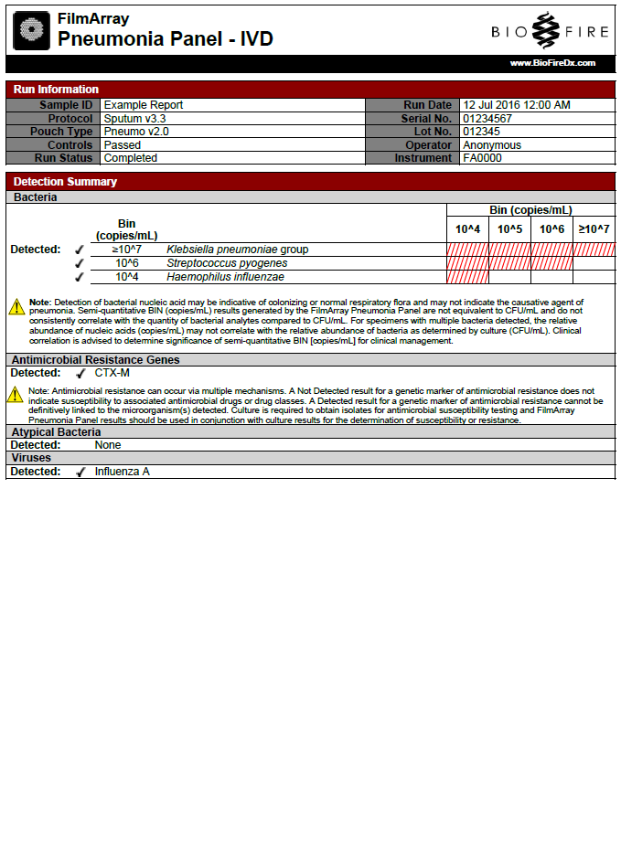
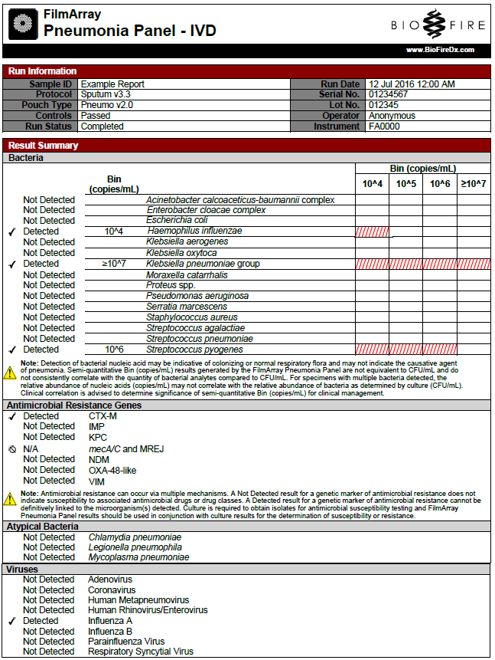
The two-page BioFire® FilmArray® Pneumonia Panel report is displayed upon the completion of a run and contains three sections: Run Information, Detection Summary, and Result Summary. It can be saved as a PDF file and/or printed if desired.
Run Information
The Run Information section is displayed at the top of both pages of the test report. It provides information about the sample and the run, including Sample ID, Protocol (sample type), pouch information (Pouch Type, Lot Number, and Serial number), run date, run status (completed, incomplete, aborted, instrument error, instrument communication error, or software error), the identity of the operator who performed the test, and the instrument used to perform the test. Control results are reported as Passed, Failed, or Invalid. Table 5 provides additional information for each of the possible control field results.

Table 5. Interpretation of Controls Field on the BioFire® FilmArray® Pneumonia Panel Test Report
Control Result | Explanation | Action
Passed | The run was successfully completed  AND  Both pouch controls were successful. | None.  Report the results provided on the test report.
Failed | The run was successfully completed  BUT  At least one of the pouch controls (RNA Process Control and/or QSM) failed. | Repeat the test using a new pouch.  If the error persists, contact Customer Technical Support for further instruction.
Invalid | The controls are invalid because the run did not complete. (Typically, this indicates a software or hardware error). | Note any error codes displayed during the run and the Run Status field in the Run Information section of the report. Refer to the appropriate FilmArray Operator’s Manual or contact Customer Technical Support for further instruction.  Once the error is resolved, repeat the test or repeat the test using another instrument.
Detection Summary
The Detection Summary section is displayed on the first page of the report and lists the Detected results under each category (bacteria, antimicrobial resistance genes, atypical bacteria, and viruses), including the semi-quantitative “Bin (copies/mL)” results for bacteria. If there are no Detected results in a specific category, the result shown is Detected: None.
Results Summary
The Results Summary is displayed on the second page of the report and provides a full list of test results for each organism and antimicrobial resistance gene including the “Bin (copies/mL)” result for bacteria. Possible results for each organism are Detected, Not Detected, Invalid, and N/A. Table 6 provides an explanation for each interpretation and any follow-up necessary to obtain a final result.

Table 6. Reporting of Results and Required Actions
Result | Explanation | Action
Detected | The run was successfully completed  AND  The pouch controls were successful (Passed)  AND  The assay(s) for the organism were POSITIVE.ª | Report results.
Not Detected | The run was successfully completed  AND  The pouch controls were successful (Passed)  AND  The assay(s) for the organism were NEGATIVE.^{b} | Report results.
Invalid | The pouch controls were not successful (Failed)  OR  The run was not successful.  (Run Status displayed as: Aborted, Incomplete, Instrument Error, or Software Error.) | See Table 5 for instruction.
N/A  (Antimicrobial Resistance Genes only) | The run was successfully completed  AND  The pouch controls were successful (Passed)  AND  The assay(s) for the organism(s) associated with the antimicrobial resistance gene were NEGATIVE so the results of the antimicrobial resistance gene are not applicable to the test results. | Report results.
ª For bacteria, the organism calculated value must be greater than or equal to 10^3.5 copies/mL for the assay to be POSITIVE.
^{b} For bacteria, a NEGATIVE assay result may indicate no amplification or amplification with an organism calculated value less than 10^3.5 copies/mL.
Change Summary
It is possible to edit the Sample ID once a run has completed. If this information has been changed, an additional section called Change Summary will be added to each page of the test report. This Change Summary section lists the field that was changed, the original entry, the revised entry, the operator that made the change, and the date that the change was made. Sample ID is the only field of the report that can be changed.

References/Related Documents
BioFire® FilmArray® Pneumonia Panel Instruction Booklet (RFIT-PRT-0575), BioFire Diagnostics, LLC.

